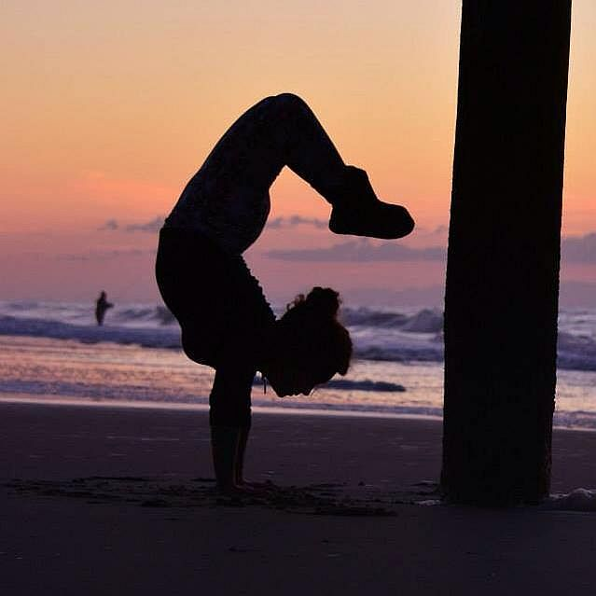
My vision board for our Sailing and Yoga Weeks ~
We will open the week with a tribal gathering, yoking all of us together. We will celebrate with an opening ceremony; setting our intentions for the week and getting to know one another. Two main themes I’d like to see come alive Labor of Love and May all beings be happy. Lokah Samastah Sukhino Bhavantu
Wake up each morning in a different sweet spot in the Abacos. Sunrise, the smell of coffee, the ocean, being one with nature. We will begin each morning with a mindful practice listening to our bodies, flowing with our breath, coming together to welcome in the new day. Then we will feast on amazing home cooked meals, explore different islands, shop, play, and come together as a tribe. Our days will be filled with snorkeling, swimming, eating, yoga, exploring new places, journaling, relaxing in the hammocks aboard the Ciganka; the possibilities are endless. I’m excited to share this journey with all of you. I’m excited to share my passion of yoga and Play, Grow, Learn, & Bloom together. The final evening we will close with our tribal gathering…setting our intentions on fire and setting them off into our final sunset!
Morning Practices – Wake up with the sunrise, salt air, and coffee/tea. Being present in the mornings, finding our breath, our intention for the day, giving gratitude, taking time for yourselves. We will begin each morning by Practicing Morning Mantras and FLOWING! Wake up and Flow into Sun Salutations. We will explore spicing up our Sun Salutations and break down differences with A, B, & C variations! Mornings will vary from Vigorous Vinyasa’s and Yummy Yin Yoga! Focusing on intelligent sequencing for proper alignment in our bodies and mind.
Afternoons are for PLAYING! We will play with inversions, arm balances, Acro Yoga, Therapeutic Acro, SUP Yoga, Dance Yoga, and Thai. We will play on rooftop bars, local’s porches, on the Ciganka, and some of the most beautiful beaches I’ve ever seen. I’ve had awesome opportunities to learn, practice, and play with some really awesome, cool teachers along this journey and am stoked to share with all of you!
Evenings we Rest and Reflect. Evenings are meant for reflection and winding down the days. We will close each day with a combination of Yin Yoga, Gentle Partner Yoga, & iRest Yoga Nidra – the sleep of the yogi. This is a meditative practice for deep relaxation and healing. I studied and practiced with Richard Miller, PhD in San Francisco in 2011, the founder of iRest and cofounder of the International Association of Yoga Therapy. I absolutely love this practice! This will be a guided meditation for self inquiry, allowing us to drift into a restful sleep.
YA Hrs for Teachers - For yoga teachers aboard or anyone wanting to deepen their practice we will include 1-2 hrs/day for Yoga Philosophy. This will include deepening your knowledge of the Chakras, the Yamas and Niyamas, yoga sutras, and meditation. This will be done either before our morning practice, afternoon, or evening … here on the Ciganka we really like to go with the flow!
I’m looking forward to our retreat aboard the Ciganka. Can’t wait to see you in the Bahamas! What are you waiting for?!?!?!?!

