The following “log” is a collection of happenings and memories that stemmed from a long time desire that I have had to experience “blue water” sailing. My wonderful wife was incredibly supportive of me selfishly taking 2 weeks and some to leave her to deal with the real world while I went away to fulfill this dream. She did, however, ask me to keep a record of my experiences. As I read through what I have written and photographed, it seems pretty inadequate, but I do hope that those who take the time to wade through this get some flavor of what I have experienced. Thank you Pat, and thank you Thomas (the Captain) and Linda (the Admiral) for an incredible time.
Wednesday, March 2nd, 2016
Day 1 - This is my second trip to the Dominican Republic. The first was fun and exciting because it was a cool birthday trip, but was basically a long weekend to a resort – giving you absolutely no idea what the country and the people are like. In fact, the resort tends to discourage much activity beyond their walls, citing crime, corruption & creating all kinds of touristic fears, mostly I think because they would prefer that you spend your money there.
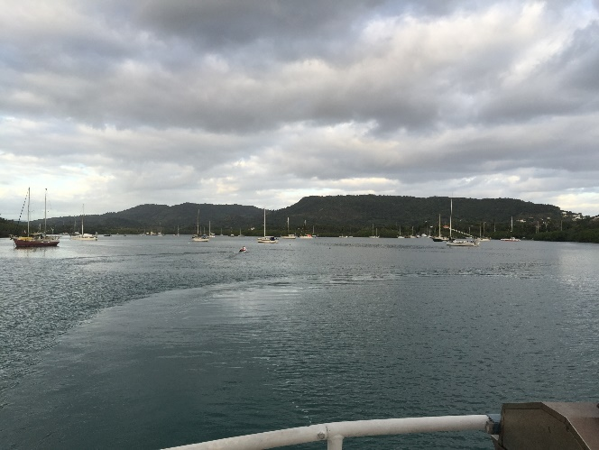
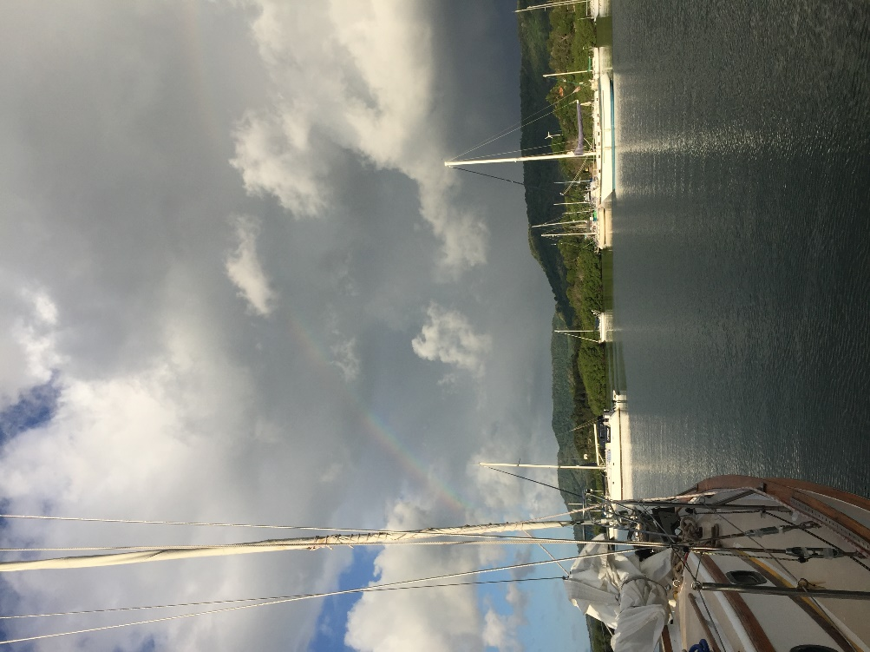
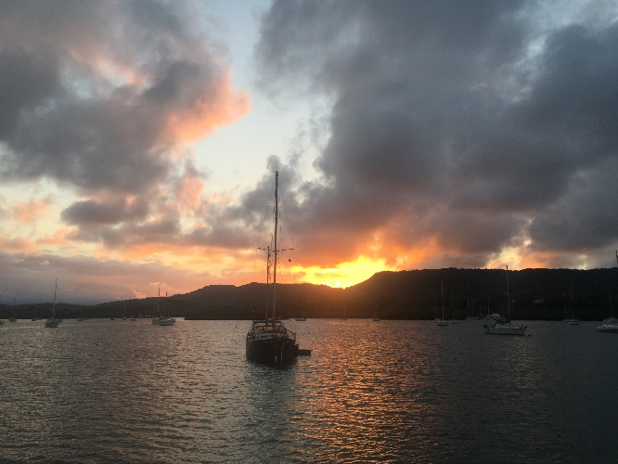
This trip was about as different as it gets. In this case I am visiting folks who are residents, living here 6 or so months a year. Captain Thomas and Admiral Linda live on their boat Ciganka near the village of Luperon. It’s a fairly poor village, but pretty representative of the Dominican, with a mostly agrarian life style. There is a small cheese factory here and early in the morning and late in the evening you see lots of traffic delivering full milk cans and returning with empties. The traffic is everything from horses to Pick-up trucks, but the overwhelmingly popular form of transport is motorbikes. As you can see, Luperon bay is just beautiful! Not only is it incredibly scenic, it is considered one of the Islands’ best hurricane holes. That designation is given to anchorages that are naturally protected from the winds and waves of tropical storms and hurricanes.
On day one, I have met quite a variety of locals and expats. On the way into town from the airport in Porta Plata, Thomas and Linda introduced me to Maria, who owns one of the largest grocery stores in the village. She and her family run the place themselves 24/7 – it’s about the size of your average 7/11, but probably couldn’t look more different. Looks more like an old fashion general store, with a few of everything. You don’t really know what the inventory looks like week to week as it’s an island, totally dependent upon imports and local produce. It’s an interesting mix of old and new though. While some of the items that you find are what you might expect in a small 3rd world village, they do have a small freezer on the counter, about the size of a microwave, with frozen Snickers, Milky Ways and Paydays.
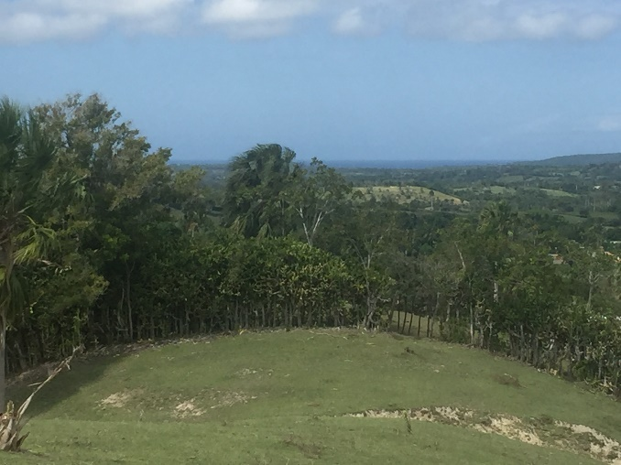
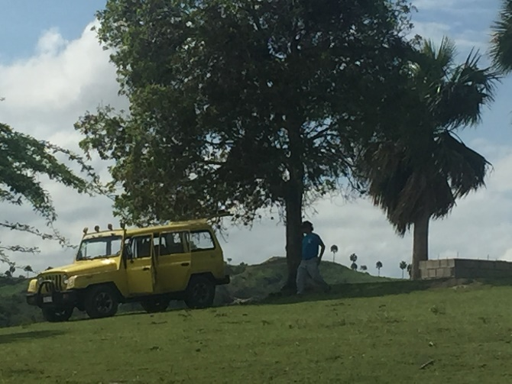
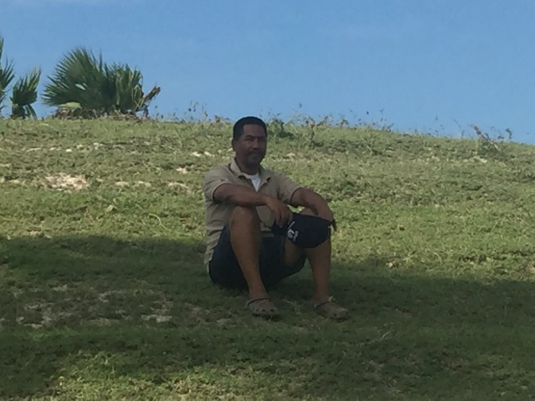
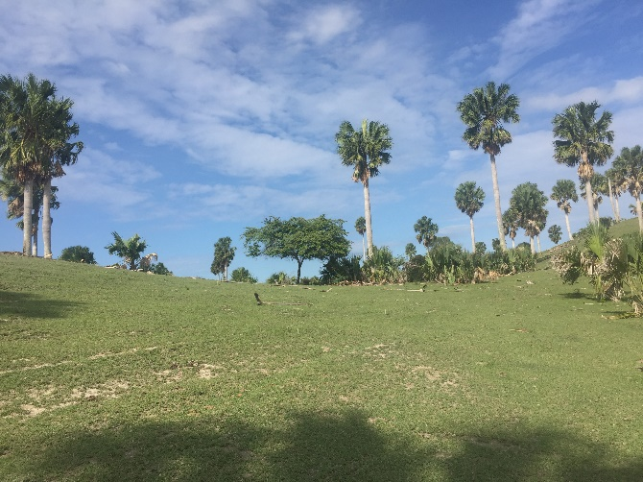
Thomas and I went out to pull his pump from the well on his property. Thomas and Linda own about
Wellhead and Thomas' jeep from the Beijing Auto Works
Joselito

30 acres of pasture land a few miles out of Luperon.

Since they will be away for the next 6 months running their sailing charter business out of the Bahamas, they were advised to pull it out to avoid theft. The purchase of the land is a story unto itself. Although they have paid for and operate the land as if they own it, they are about 7 years into the actual transfer of title – all due to personal and political issues w/in the system, not necessarily with them. They finally employed Joselito, a local attorney to help them with the case.
What a guy! As nice as can be, he took the time to go and help Thomas and I pull the pump. Joselito is friendly, obviously smart, and a lawyer, but he took time off to help Thomas. I teased him about an attorney getting his hands dirty – his reply – “Thomas is my friend”. Later, during dinner Thomas and Linda related his story. About 11 months ago his 45 year old wife went in for jaw surgery and died on the operating table, only to be revived – but for the last 10 months she has been in a coma with a breathing and feeding tube. Not being in a position to be able to afford help, Joselito feeds, changes, exercises and cares for her every day – by himself. You would never know it to talk with him. That’s an incredible burden that he carries alone, and does not show it in any way.
We took the pump and tubing to a couple who are great friends of Thomas and Linda for storage while they’re away in the Bahamas. Rudy and Margaret live here permanently on adjoining property – originally they’re from Germany and Zurich respectively. They sailed all over the Caribbean for years, but as they say, they are just getting too old. They’re in their 80s. During the course of the day, I met a number of their expat friends. And very much like the expats that I have met in other 3rd world countries, they are folks who move to a different beat, recognize the difficulties and deal w/ them in such a matter of fact way it’s amazing. And they all love it here.
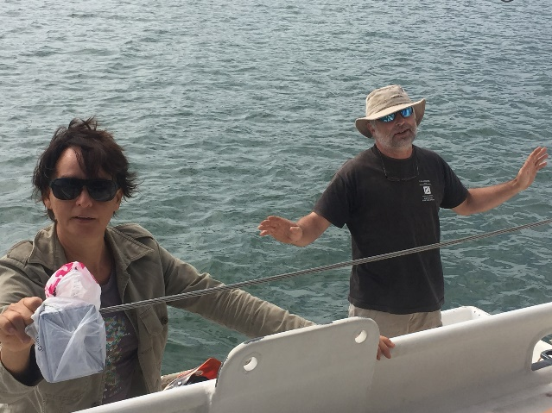
One couple, Olivier (French) and Natalie (French Canadian) live on their boat too, but also have a shipping container (full size) on some land near the marina where they have all their tools and diving equipment. He’s a pilot, flying back and forth from North America to Europe for a few months, and then comes to the DR where they have run a dive school, but do so no longer. When he’s gone, Natalie continues on, working on the boat and the container.
Their philosophy is that when it’s time to move on, they’ll ship the container to the port and country they are headed to, and sail their boat there so that they can re-open their workshop and continue on. While I’m lucky enough to have seen these type of highly adaptable, and adventurous people in a number of places around the globe, it’s always fascinating and always a joy to meet new ones. These are folks for whom the rat race just doesn’t exist. They do their own thing, in the places they want to, the way they want to do it. Fascinating people!!!

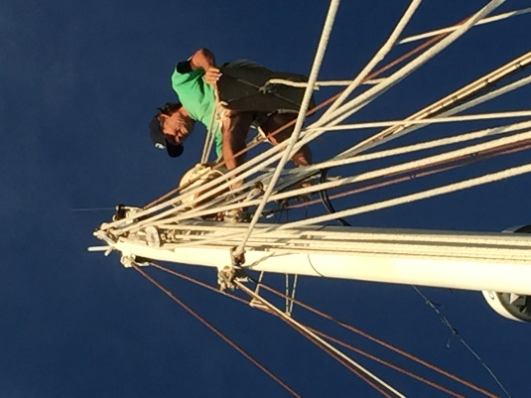
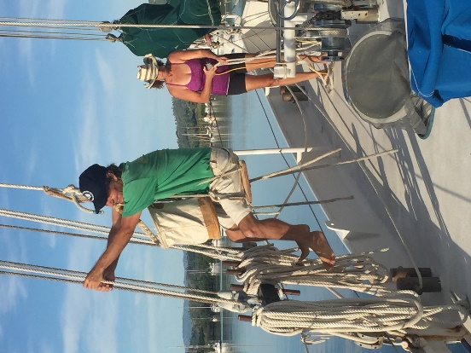
Thursday, March 3rd, 2016 Day two.
We spent some time this morning getting the boat ready to sail. You can see Thomas, with a little help from Linda, going up in the boson’s chair to make sure all the blocks are lubed and free. Then Thomas and I went out to get the gas and propane tanks filled. Do this at home - so what – no big deal. Here, it was a much more interesting experience. Now, if only the wind will cooperate. Thus far, the forecast is still for little to no wind for the next 2-3 days. Everyone is getting a little impatient and we are ready to GO!
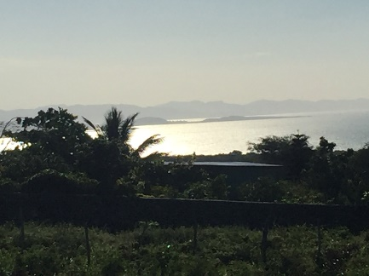
As a nice break this evening, Thomas and Linda took me to the next bay north along the coast. This is the bay that Columbus sailed into and alongside of the bay is the oldest church in the Americas. But, I’m getting ahead of myself. On the road to our destination, we stopped at one of their local friend’s house to drop off a couple of coloring books and crayons to his young son. This gentleman is a farmer, and Thomas said he has taken a couple of days off to walk with him over his property and point out things that will help Thomas when he starts up his cattle operation next year. Again, here’s another local who won’t take any money for his time and effort, he does it for friendship.
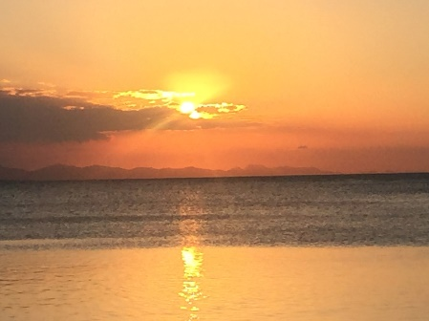
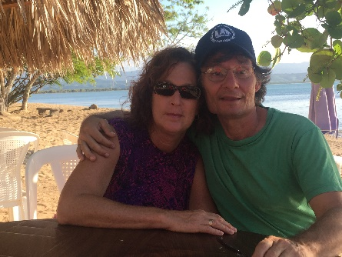
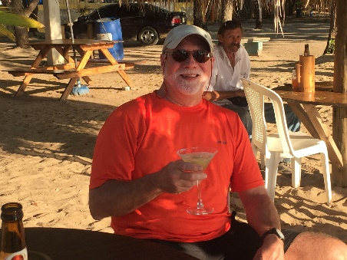
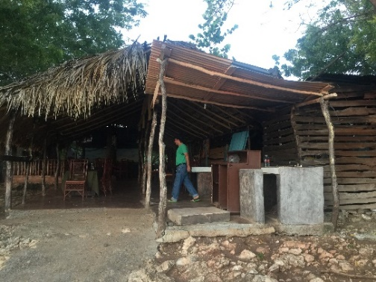
From there, down to the bay. We first stopped at the restaurant that we were planning to eat at to tell the owner, and chef, Marlen, that we would be there for dinner and to pick out our fish.
We ended up settling on a large snook, that she would later cut into steaks and prepare for us. After that, a brief respite at the bar down by the water for a refreshing beverage as the sun went down.
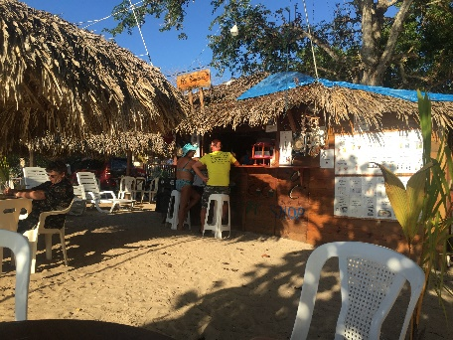
Of course, this adventure would not be complete without a story. Word is, the guy sitting at the bar was a narcotics officer in a European country that shall go unnamed. He participated in a massive bust, which put him in extreme jeopardy with the criminal element of that country. So he’s essentially in witness protection, living on his normal salary, which makes him a rich man in the DR, essentially hiding out from the mob.
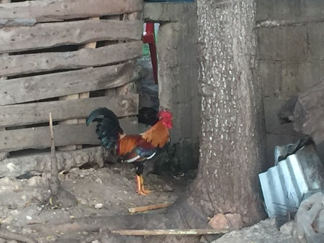
Then on to an absolutely delicious dinner of fish, potatoes, plantains and salad. Oh, did you think that this is a fancy restaurant? Well, not so fancy, but some great fowl running around outside, a neighborhood dog that politely beseeched us with those puppy eyes for some handouts, which he of course received. Sorry, no picture of the dog. Marlen was a wonderful hostess, and at least as good of a cook. We were the only ones in the restaurant that evening. Afterward, there was a long slow drive home that we spent looking for cows in the road and for tarantulas, which come out in the evening, seeking the warmth of the roadway. Unfortunately it was too early and while we did see many cows standing and sleeping in and around the road, there were no tarantulas.
Friday, March 4th, 2016
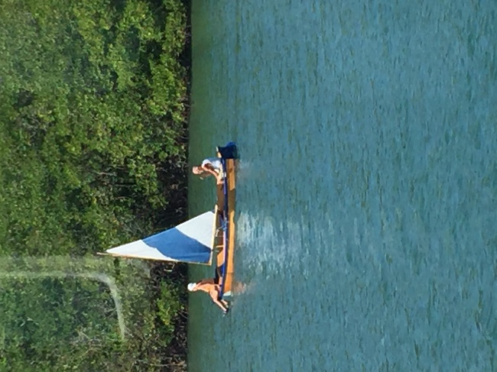
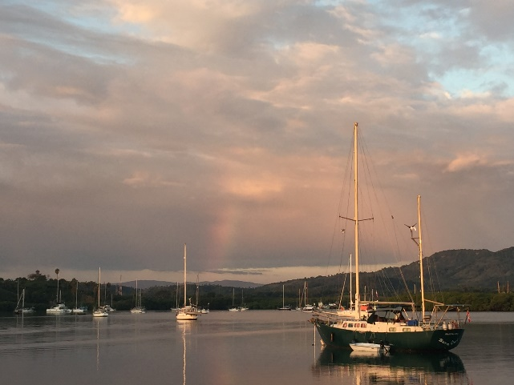
Day three. Friday was pretty much of a down day for me. Thomas and Linda had some errands to run and chores to do that I couldn’t really help with so I chilled on the boat and did a little more harbor watching. Since the internet was good, I did a little work. I’m not saying that I really felt like it, but there were some loose ends hanging and this game me a good change to take care of those – and avoid some guilt - you know how powerful that can be.
Friday evening, however, we were invited to go out to a house that was abandoned for about 7 years and then 2 years ago an Italian gentleman began renovating it for use as a B&B. It is right on a rocky coast, past the restaurant we went to the previous evening, the next to the last house and seemingly close to the end of the world. At any rate, we were invited, with about 10 other expats to a pizza party. The pizzas were prepared by the owner in a brick oven that out back near a large, but empty swimming pool. (It was empty for cleaning I think and scheduled to be refilled later that week, but I digress.)
Frank’s, our local pizza joint on Broad Creek, NC will never have to be worried about competition for his pizza, but it was fun to talk to all the folks that were there. Some of them I had already met, and the conversation was good, which compensated for the pizza. That was definitely the latest evening of the week, and we didn’t get home until around 11.

Saturday, March 5th, 2016
Day four. Thursday evening at dinner, Thomas had a temporary tooth crown fall out, which resulted in today being spent as a road trip to Santiago. Early this morning, Thomas, another boat dweller named Lynne Bourne and Joselito got in Thomas’ “Beijing Burner” and headed out. It was a beautiful trip that took us across a mountain range in the center of the country. Joselito told us that the scene in Jurassic Park where the helicopter descends beside a waterfall as they first go to the island was filmed near where we were. There is a hiking trail in the mountains that encompasses 27 different waterfalls that sounds like a must do if there’s a return. Lynne said it’s a great hike.
Lynne needed some wood for a boat project so the first stop was a pretty large lumber yard on the outskirts of Santiago. Interesting factoid here; when you purchase a 2x4 in the DR, it actually measures 2” by 4”. How novel! We had not been there 5 minutes when the security guard brought to our attention our flat tire. It wasn’t low – it was done. Later we found out that the sidewall had totally blown out. We were fortunate that it didn’t happen along the trip. I won’t spend too much on the hunt for a spare, but suffice it to say that this added 2-3 hours to the trip.
Once that was done we went to a hardware store called Ochoa to pick up some items for everyone but me. To call this a hardware store is kind of like calling the largest Home Depot a local Ace Hardware. This place occupied 2 city blocks - just enormous! If it goes in a home (other than food), its there. I was pretty impressed with the prices as well. If you go to most islands, whether it’s a small island in the Bahamas or Australia, everything is really high priced. (Quote from Harrison Ford’s character in “6 Days and 7 Nights” – “It’s an island babe, if you want it here, you bring it here.”) Here, I was amazed. Some of the hardware, (e.g., a Bosch drill), was actually less than I would expect to pay at Home Depot in Raleigh.
Next we went to a mall, of all things, but that was to go get some lunch at the food court. This was for Joselito, as apparently he really liked the oriental place we went to. For the most part, it looked like any mall anywhere. It was worthy of note though that while we were sitting there waiting for our food, this small rat came out of one store and scampered across the center of the mall. I don’t even think he got kicked or stepped on. Not so sure that I would want to go to mall late at night alone, the wildlife could be dangerous.
Then, finally Thomas was able to address the purpose of the trip, his tooth. He and Joselito went to the dentist so Lynne and I went to the local supermarket to get a beer, shoot the breeze and wait. This gave me an opportunity to talk w/ Lynne and learn her story. She and her husband lived in Mebane, where he was VP of sales for one of the furniture companies in NC, and she actually worked in the factory building furniture. They later moved to Beaufort, where she began working in one of the boat stores there and became known to sailors as “the Boat Lady”. Great small world story here. One of her sons became a professional skateboarder and during the course of his career, skated with and was one of my son-in-law’s skateboard heroes. I sent Marcus a text to let him know and he recognized the name immediately. Lynn’s husband died a number of years ago, after which she single-handed her sailboat around the islands. When she arrived in Luperon, she fell in love with the place and has lived there on her boat for the last 9 years.
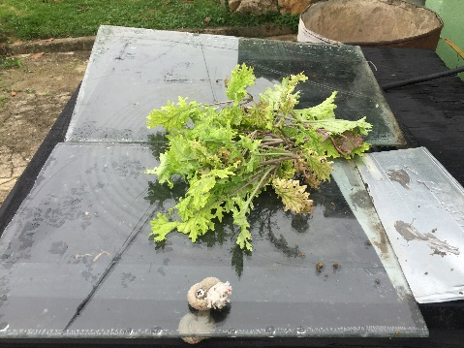
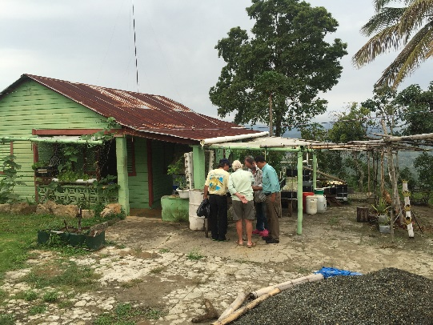
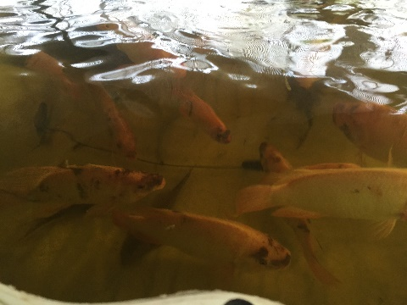
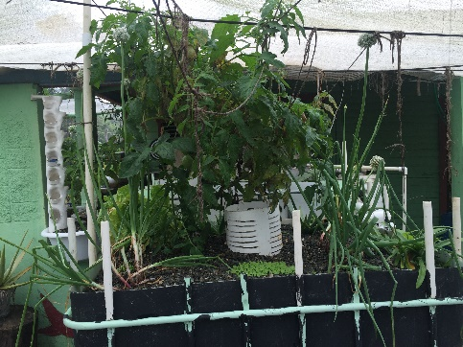
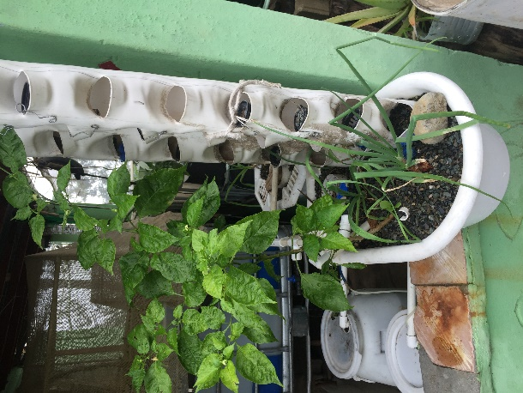
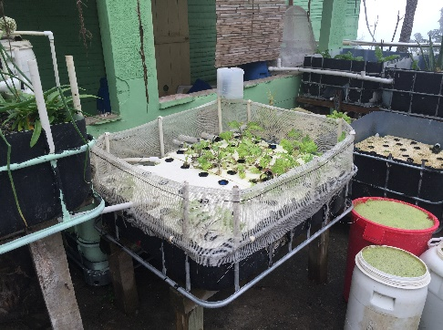
I guess that discussion was the start of “meet some characters day”. When we left Santiago, we went up into the mountains to visit a friend of Thomas and Linda’s named Willie. He has lived in the DR for 35-40 years and is a real mountain man. He has virtually no money or teeth, and is getting cataracts, so he can’t see particularly well, but he is very actively and passionately involved in developing sustainable aquaponics. He has developed systems that grow tilapia, and then use the water and the waste that the tilapia generate to feed his hydroponic garden that contains lettuce, kale, hot peppers and squash. The entire system is built from used 250 gallon totes used for storage and shipment of pesticides and other chemicals. He uses the internet to communicate with scientists around the globe who are involved in this endeavor, and while it looks crude and a bit Rube Goldberg in construction, both the science and execution are amazingly effective. His goal is to fully develop the system and then share it with the people of the DR, so that they may better be able to feed themselves in a very cost effective manner. He and I had some great discussions around how he controls his pest issues and it has already resulted in some interesting email exchanges. He gave us some kale and Lettuce, which Linda put into a pasta dish and salad. The production system may be a little different, but the output was excellent!
By the time we got home, this 80 kilometer trip to Santiago had turned into an 11 hour odyssey, but it was very interesting, albeit tiring.

Sunday, March 6th, 2016
Day 5. Sunday was another down day, so not much to say although this is a good time to say just how terrific Thomas and Linda have been to bring me into their home for such a long time. They are great company and have really taken good care of me.
A few friends including Jeff and Lucas, who build charter boats at their factor here in the DR came by on their kayaks to say goodbye.
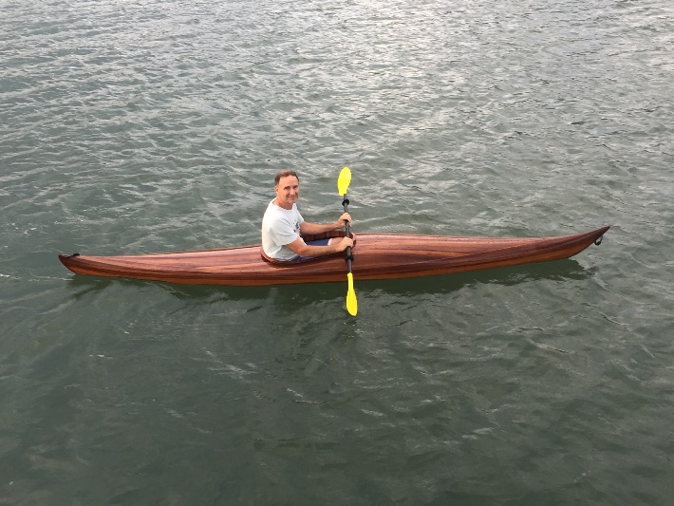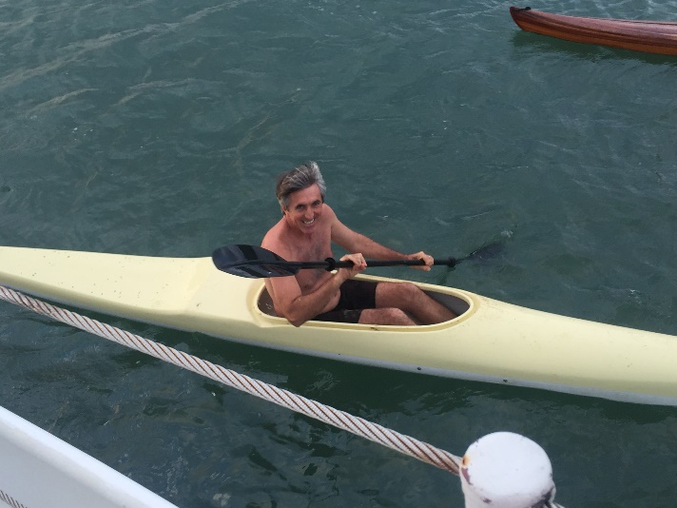

Monday, March 7th, 2016
Day 6. One frustration that Thomas and Linda share with a number of other boat residents in the Luperon Harbor is a guy named Papo, who works in the Harbor. Thomas and Linda have a very heavy sailboat (70 tons vs 10-15 max for most commercial cruising sailboats). As a result, they don’t use the moorings in the harbor, but instead use their own anchors. While this works, it’s a real pain. They are usually there for 6-7 months / year and you would be amazed at the barnacles and other marine life that attaches themselves to the anchor chain. When they pull in the anchor to head out, they literally have to use a chisel and stiff brush to clean every link that’s been exposed in the water. If not, the barnacles die in the anchor chain locker and fill the boat with the stink of rotting seafood. For the last few years, every time they leave a good anchorage, within a week, Papo comes in and puts a mooring there. He wants them to pay him for the mooring, but apparently can’t seem to understand that the weight of their boat makes this impossible. This year Thomas, Olivier and another captain came up with a strategy to build a mooring system that will handle the weight of their boat and give them permanent moorings that Papo won’t be able to steal or screw up.
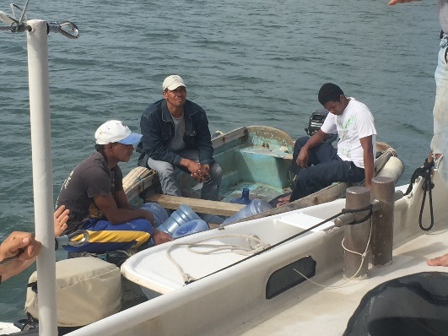
This resulted in Thomas, one of their DR friends and helpers named Domingo and I mixing concrete and filling a 55 gallon drum, which formed the center piece of the mooring. That had to sit for 2 days before it could be dropped in the water and though it’s really a story for a couple of days away, I’ll go ahead and tell you about getting this the water. This drum of concrete weights about 1,000 lbs. Domingo, another local friend called Handy Andy, and one of his workers rolled this drum about 2 blocks down a fairly steep hill, rolled it onto the dock and from their onto some boards placed across an old engineless boat that was towed to the right spot and dropped into the harbor. It was rigged with a chain so that Thomas could then use his power anchor lift to pull it up off the surface, position it correctly and drop it exactly where they wanted it. Unfortunately we missed the actual rolling of the drum – that would have been interesting to see.
Domingo, Handy Andy and Jorge
Tuesday, March 8th, 2016
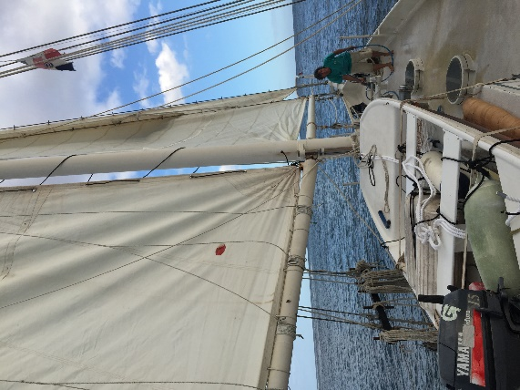
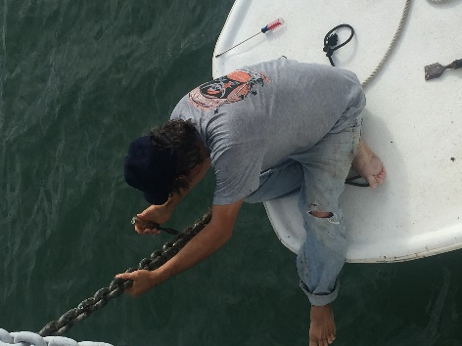
Day 7. Finally, the last day before departure. The day was spent just getting ready – including, the aforementioned cleaning of the anchor chain, bringing the dingy onboard, doing all the exit paperwork, and stowing gear. Poor Thomas, it was one of those days that no matter how good you are, everything that you touch goes wrong. There was a new customs guy, and he was taking no chances so an extra trip plus 1,500 pesos was required to get yours truly cleared for departure. The pin used to arrest the turning of the prop while under sail broke while the drum was being dropped – that happened today as well. The small generator broke down, and the vacuum cleaner that he was using to clean up behind repairs broke as well. But finally, everything was done, and we were ready to go. The plan is to get up early, close up the boat to prevent taking in water via hatches, etc. and clear the harbor as early as possible. The first day we hope to make about 130 miles and reach the Turks and Caicos in the first 24 hours.
Wednesday, March 9th, 2016
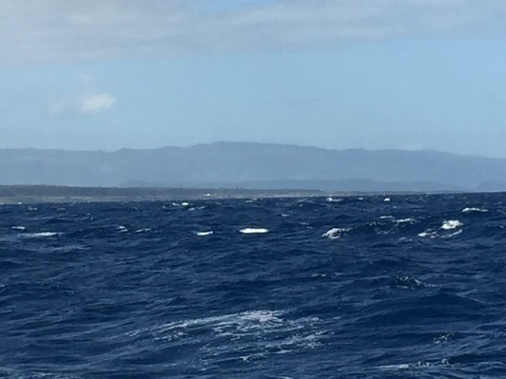
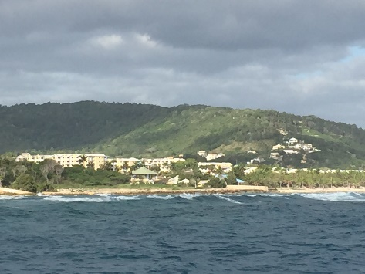
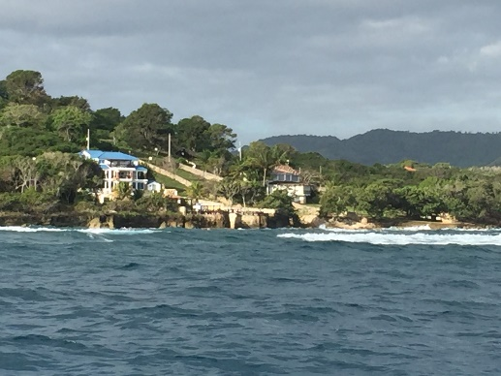
Day 8 (Day 1 of the voyage) Can you say GREAT SAIL!!! We cleared the last buoy in the harbor at roughly 8:30 in the morning. In the first 24 hours we covered 202 miles! According to Thomas and Linda that’s only the second time they have made that distance in 24 hours. The wind – at least in my estimation – was honking! I think it was another day at the office for Thomas and Linda but for me – well, this is why I came. We operate in watches, 4 hours on and 8 hours off, which means that a day watch and a night watch. At about dark, near the end of my first watch, the wind and waves were such that the auto-pilot wouldn’t hold. Thank heavens that Thomas had told me that this may occur, and told me what to do in case it happened. Nonetheless, while Thomas and Linda were down below napping I’m sitting there in the midst of excitement and frankly a little apprehension. I have never conned a boat of this size, especially in 30 knots of wind and of course as I’m just starting to relax a little – the alarm goes off, releases the wheel and it starts turning like the wheel of fortune. Can you say “oh s__t”!!! And also “Please God, don’t let me screw up.”
Got it under control, but I won’t say it was graceful or easy. Finally it was blowing so hard that we shortened watches, and thank heavens Thomas and Linda took pity on me and helped me through mine. (Well, they were probably were more concerned about their boat – for which I both understand and am grateful.) At the peak of the wind and waves, Thomas was steering the boat. Earlier I mentioned that he had to go in and fix the prop arrestor before we left. At one point during the evening, we hit 14 knots – and the arrestor blew again. As it turned out however, this may have been a good thing. Once the prop began turning freely, the resistance on the helm reduced and steering got easier for us and the auto pilot. And after all that, they still went to bed and let me solo the 3:00AM-7:00AM shift.
Did I say anything yet about sleeping on the boat while going through this weather? It bounced, and sounded like you strung a hammock over the busiest subway in NYC and tried to sleep. I told Linda that about every 30 minutes it sounded like someone dropped a load of lumber on the deck over my head. I think that was the staysail boom slamming, but I wasn’t going to put on a safety line and go look. So I got about 3 hours of sleep. Which is to say that if I hadn’t been so scared, I probably would have drifted off during my watch. And of course throughout this, Thomas and Linda are sleeping like babies. (Well, Thomas did come up to check on me (ok, the boat) a couple of times.)
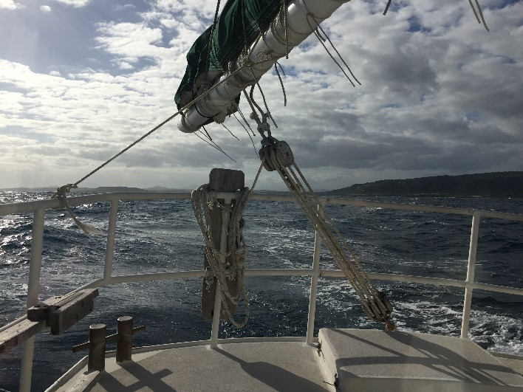
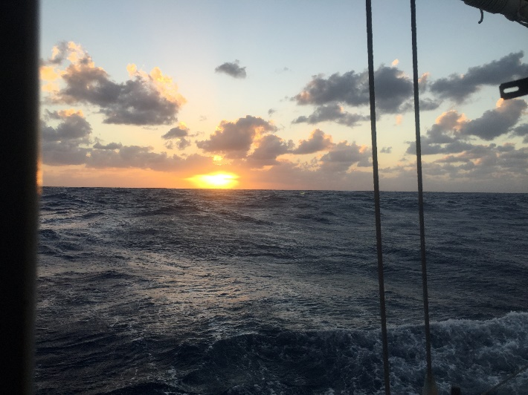
During the highest wind and waves, we had swells that were easily exceeding 12 feet. But, for some reason, it’s almost impossible (for me anyway) to take pictures that really show the size of the wave. I asked Thomas and Linda about it and they said they share the experience. That hasn’t stopped me from taking a million pics and videos, so maybe one or two of those will give a hint.

Thursday, March 10th, 2016
Day 9 (Voyage day 2) After yesterday’s near record pace, we expected things to slow down. And they did, but not too much. We’re still clipping along at 7 knots, and though it feels slow, we are eating up the miles. We
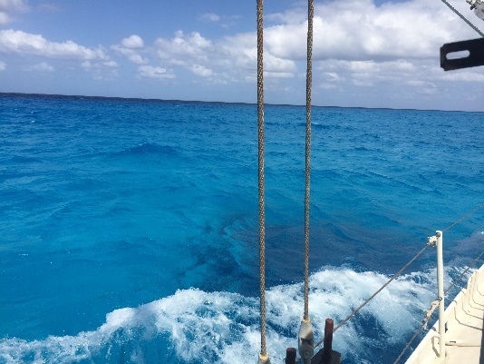
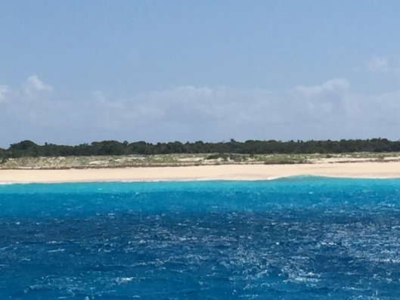
made such good time that we passed west of Great and Little Inagua and inside (east of) of Turks and Caicos during the evening, passing just inside Mayaguana Island early Thursday morning. Early afternoon we passed very close on the inside of the Plana Cays, and got our first look at that incredible turquoise colored water that makes the Bahamas famous. No matter how you think you’re prepared, it never fails to be stunning.
By the way, Islands are distinguished from Cays (pronounced “keys”) by whether or not fresh water is found there. Cays do not have fresh water found naturally.
Later that afternoon we passed between the Acklin Islands to the west, and Samana Cay to the east. After that we made a long run north northeast, passing between Rum Cay and Conception Island to the east and San Salvador to the west. All in all 24 great hours of sailing. We have now been travelling for nearly 48 hours, all on the same tack, and we’ll continue on that same tack tomorrow.

Friday, March 11th, 2016
Day 10 (Voyage day 3). Today began with us sailing along the eastern shore of Cat Island. That island extends roughly 20-25 miles and we’ll track along its full coastline, going from there to just off the east side of Eleuthera, which we should reach around 4:30 this afternoon. The sailing so far continues to be excellent.
It’s really peaceful out here and other than seeing 2 ships each night, we are essentially alone with the flying fish and a few birds. We continue to stay alert for dolphins, whales or other sea life, but so far nada. From a sailing perspective though, this is everything that I hoped it would be and more. Just terrific!!
We just had a brief rain shower. The rain is great for washing off some of the salt that accumulates on the rigging and pilot house windows. In looking at the notes from the last couple of days it occurs that someone reading this might raise the question of just what we do while the boat is rolling along. And there’s no question, we have a lot of time on our hands. So we watch the water and sky, we read, we read some more, we nap (there’s no doubt about it, the watch schedules really break up the old sleep patterns) and we talk.
I think that we have pretty much solved many of the world’s problems – especially the election. Thomas and Linda have Sirius radio on the boat an there’s a lot of talk radio, especially around the presidential race. We have dissected the candidates, ended the race, and pretty much dismantled Washington. In the classic sense of the Republican Party’s original believe in states’ rights, we’re pretty much in agreement that DC is too big and powerful. Beyond that, while we may disagree on lots of stuff, there’s only healthy discussion. Great discussions though.
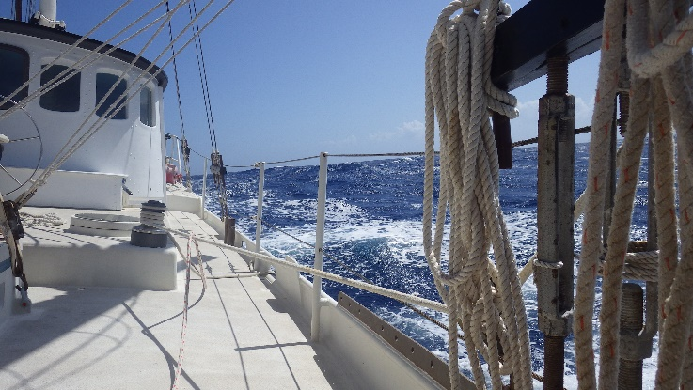
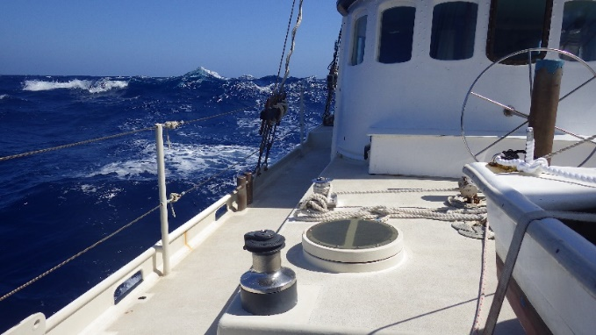
After we passed Cat Island and started on to Eleuthra, and after about 50 pictures I finally got a couple that at least hint at the seas we’re sailing in. Ciganka rides great. Sleeping is another story. I think a used an earlier analogy of what the boat sounds like, particularly when the wind drops off a bit and the waves are still high. As the mast rocks back and forth, the wind is unable to keep everything taut, so there is a lot of sail flapping, boom swinging and rigging clanging. I have another analogy that may fit better. Imagine an enraged monkey running around the boat with a hammer and a length of chain, madly swinging both arms as hard as he can go.
By the way, this may sound like bitching – and perhaps in the wee hours of the morning it is, but this is just part of sailing - it happens on every sailboat. On the open ocean however, there’s not an option of throwing out the anchor and bringing down the sails for a relaxing sleep – again, it’s part of the deal.

Saturday, March 12th, 2016
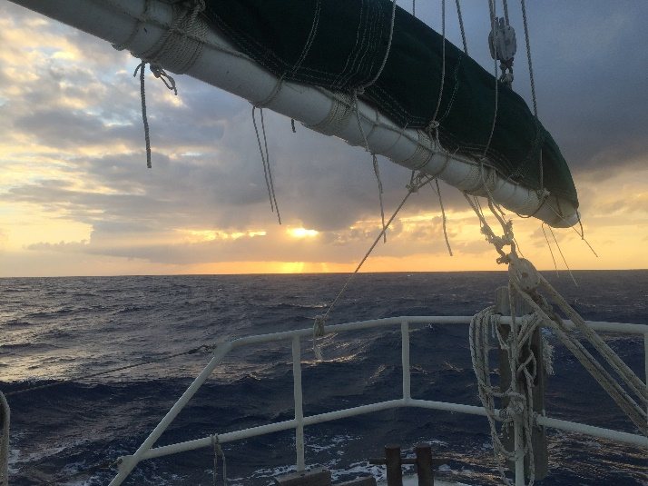
Day 11 (Voyage day 4) This will be the last day of ocean sailing. On my last “blue water” watch, the sun came up to a calmer sea, and wind, but we were still clipping along at 5-6 knots. In case you’re curious, Ciganka has 4 working sails, in order from the bow a jib, a staysail and the mainsail, all of which are on the forward mast. Behind the pilothouse is a second mast with the spanker sail. During the ocean sail, the spanker wasn’t used. In stronger winds, the spanker can actually work against the autopilot by pushing the stern of the boat off course to the point where the autopilot can’t correct. At that point it releases the rudder, sets off the alarm and the wheel must be grabbed quickly before the boat turns into the wind, or worse yet, causes the boat to gybe. A “jibe” is when the boat turns across the wind from the stern, swinging the sails to the other side of the boat. When done properly, it’s a very efficient way of turning the boat to take advantage of the wind from a different side of the boat. If it happens without controlling the sails, particularly the mainsail, it’s a fast and violent move, which can literally snap the mast in two. Needless to say, this must be avoided at all costs. So to get myself back on point here, the sail you see in the picture with its cover on is the spanker.
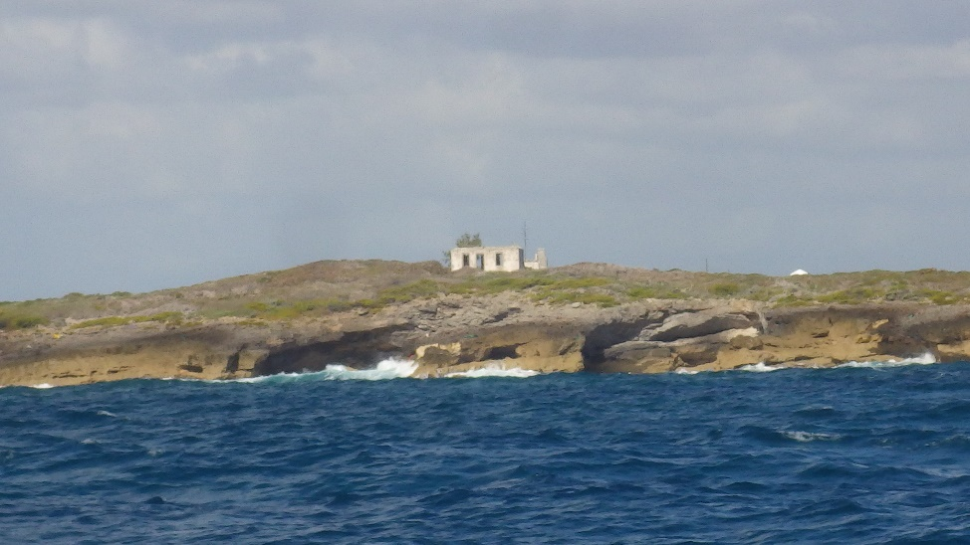
Not too much later, and almost exactly 3 days and 1 hour after we departed Luperon Harbor, we entered Little Harbor, in the Bahamas and from their our sailing will be “inside” of the outer reefs, making the sailing very smooth, and in some cases even faster as the boat is no longer going up and down, disrupting the wind flow over the sails. If you were on last year’s Yoga Cruise, Little Harbor is where the Bronze museum, and Pete’s Pub is. You ladies did yoga in the morning on the roof of the bar. That’s also the place where we stopped alongside a sailboat in the harbor and the guy on the boat showed us some amazing brightly painted fish sculptures that he made out of various local woods. The building above the cliff is the remaining structure that used to be the Little Harbor Lighthouse. It’s also the last view of truly blue water that we’ll see on this voyage. From here forward, it’s sailing in the turquoise blue waters that the Bahamas are famous for.
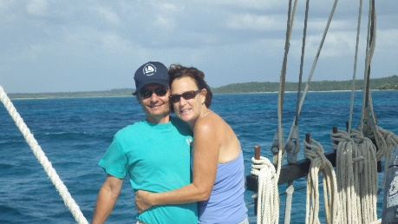
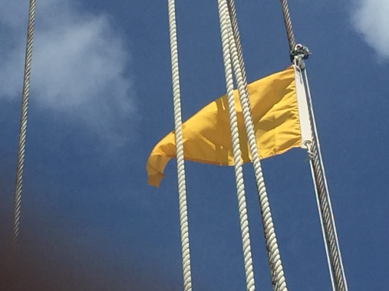
We’re not done though. We have to sail north about 35 miles to Green Turtle Key, where we’ll clear customs. As we got into the harbor and began sailing north Capt. Thomas took down the Dominican Republic flag that Ciganka had been flying and replaced that one with a yellow one. The yellow flag is the international flag that stands for Q. In this case, Q stands for Quarantine, which is the signal that we have yet to clear customs. Until we do that, technically we are not allowed to leave the boat and get on land. So as I type, we are making our way north to Green Turtle Key.
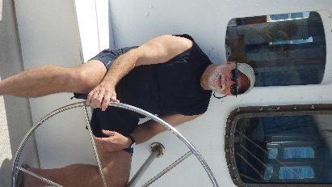
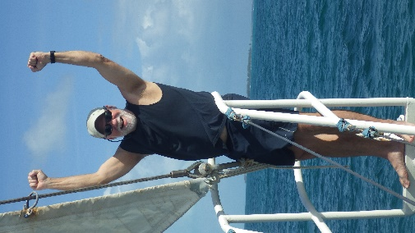
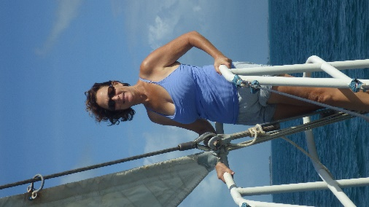
The Bahamas are Thomas and Linda’s second home, and it was fun to see us all relax and begin to enjoy the sights, the beautiful water and a totally different kind of sailing. Linda immediately headed for the bowsprit to look at the water and the sights, stopping only long enough for me to get a quick picture of the Admiral and the Captain. There were definitely some happy faces all over the boat. One of the things about ocean sailing is that there is very little time spent on the deck of the boat. With the wind, waves, spray and constant motion, the opportunity to go over-board is quite real, so we all enjoyed the chance to get out in the sun and fresh air. And I’m not kidding, thanks to Thomas and Linda I was provided the opportunity to make an ocean sail, something that I have always wanted to do. So yep, I’m one happy and lucky fellow. Now, the sailing is easy, the water is beautiful, there are boats everywhere, and there’s a sense of accomplishment with all of us.
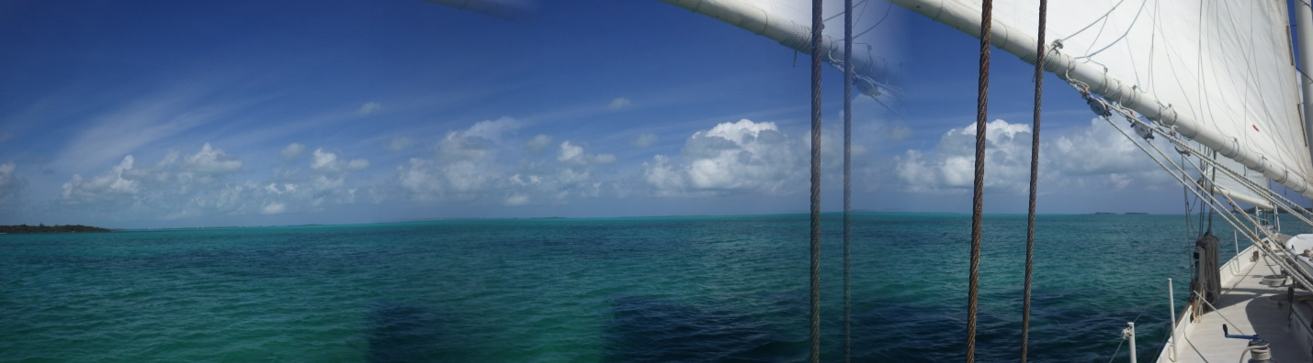
Welcome to the Bahamas!!!

See next page….

Sunday, March 13th, 2016
Day 12 One thing about this rocking and rolling ocean crossing that we made. There just wasn’t much quality resting going on. Last night though – OMG – the boat was still and quiet, the hatches could be opened to let in fresh air, the temperature was cool enough to require a light blanket, and I think all three of us slept the sleep of the dead. I know I did. I didn’t really realize just how tired I was. Thinking back to the guys who used to leave for 2 year whaling hunts, without ever touching land – they were tougher than I am – that’s for certain.
Thomas is off clearing customs. When he returns we are headed to Man Jack Cay, for a day of exploration and beach walking. It will be interesting to see how “stable” the land will be after the last few days on the boat. Land legs here we come.
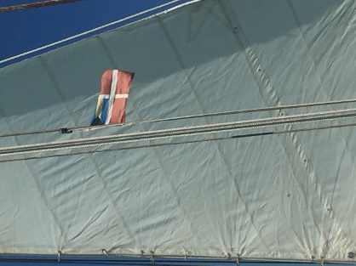
We’re official now. The yellow quarantine flag has been replaced by the Bahamian flag, so we are free to move about the islands. Now that we’re legal, we hoisted the staysail for about a 2 mile sail from Green Turtle Cay to ManJack Cay. With only the staysail, it’s a smooth, slow, quiet sail downwind, giving us an opportunity to observe Green Turtle and just relax and enjoy the ride…
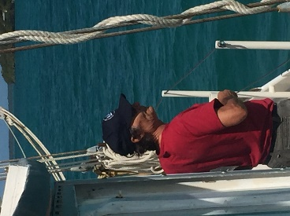
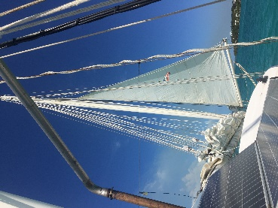
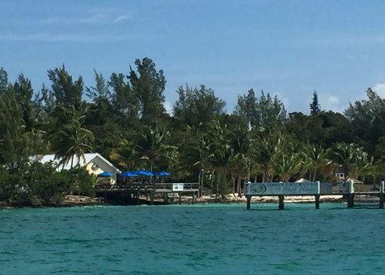
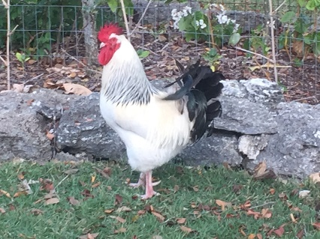
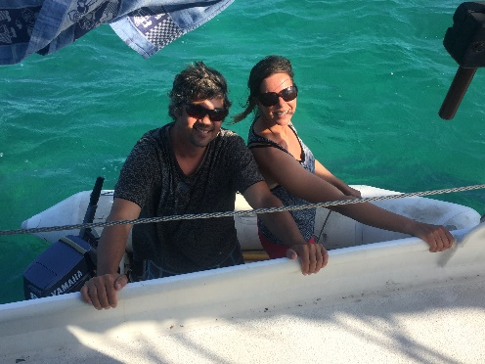
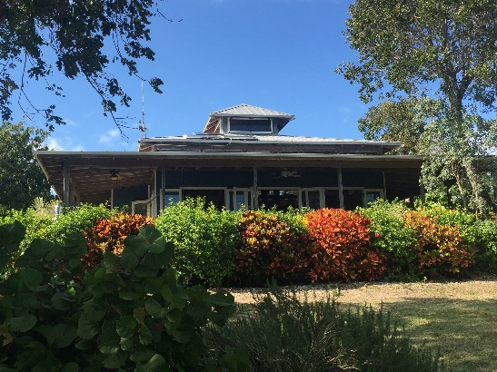
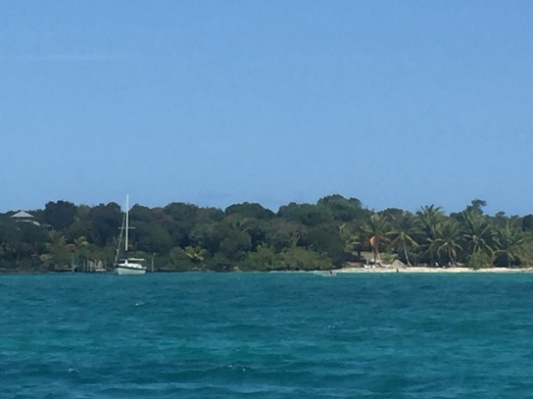
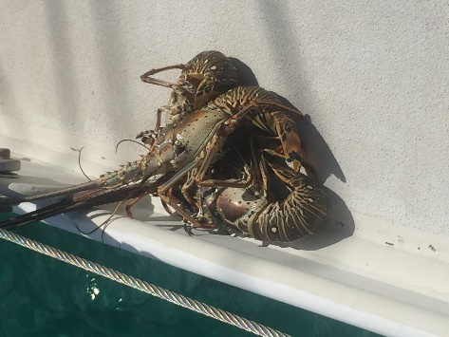
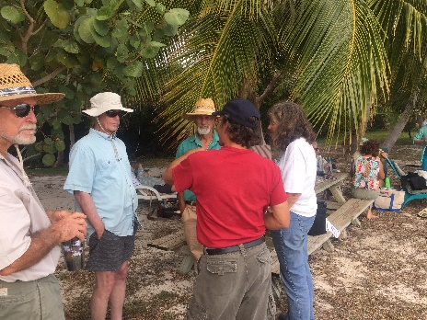
Still a quick trip, we made ManJack, dropped anchor and took a little time for a light lunch and a quick nap. Every time we stop at a new place, I’m continually amazed at how well known Thomas and Linda are. They have friends everywhere! This was demonstrated once again when, without even hailing anyone on the radio to announce our arrival, 3 of their friends, Phil – a California surgeon, and Nancy and Gilles, from Quebec stopped by the boat to drop off our dinner. I mean, really?? They were on the way back from spearfishing for lobster, saw the boat and gave us 3 out of their bucketful. Once these guys were stored in the cooler for later, we headed ashore to visit some other longtime friends, Bill and Leslie. They have been living on ManJack for quite a while, and their place showed it. Wow. The beach was covered with Palm trees that they planted when they bought the property. They are pretty interesting folks, who used to do chartering around the islands but have now retired here. They have a large piece of property that they acquired before the Bahamian government disallowed foreigners to purchase more than a 5 acre tract of land. Their property on the end of the island has water on 3 sides. A beach on the south, bluffs facing the west, and a mangrove surrounded creek on the North. They actively encourage visitors to come and enjoy their property. Perhaps their attitude is best displayed by the name of one of their boats, “Sea Story”. They collect them and share them with all except the people they find boring. When we arrived there was a group of visitors from Maine, “Mainiacs”. Many of them work for or are associated with the magazine “Wooden Boat”, and the magazine’s founder, John Wilson, was there with them. Within about 5 minutes, Thomas, who worked for a while in Maine as a sailmaker, found that he either knew, or knew someone that everyone in the party knew. It’s a little tough to make out, but you can see the beach with the palm trees, their largest sailboat and in the far left, the top of their house peeking out of the trees. This is no island shack, believe me. The house is unbelievable, and looks far more impressive from the inside than from the outside, which ain’t too bad either. Their home is totally solar powered. The have an incredible garden and collection of fruit trees, along with a very tame group of chickens (about half of them are quite happy to be held and petted), for their supply of eggs and the occasional chicken dinner. Like most folks who live on the islands, they are have great ingenuity and craftsmanship in building what they need from whatever they can find. In fact, while we in the states talk more and more about things like “sustainability” as it relates to aspects of our life, for these for these folks, it is essential to their existence on the islands. They often take folks in that they take a liking to, allowing them to live in their guest quarters for a while, and usually, in exchange, their “boarders” contribute to the place by making or building things around the property that make life better.
Gilles and Nancy
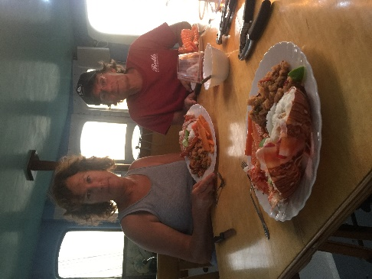
In this picture, Bill is on the left, John Wilson is in blue talking to Thomas, and the other couple is moored off the property in their catamaran motor cruiser, wooden, that they build in Maine and have sailed down to the islands to enjoy the cruising opportunities that the Bahamas provides. After a few hours of sea stories, we returned to the boat for a delicious lobster dinner.
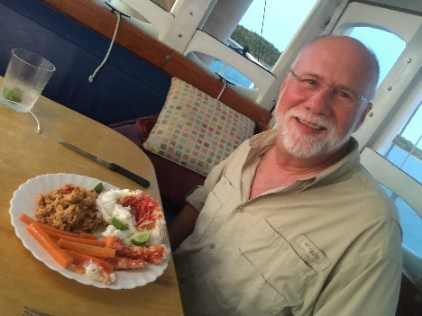

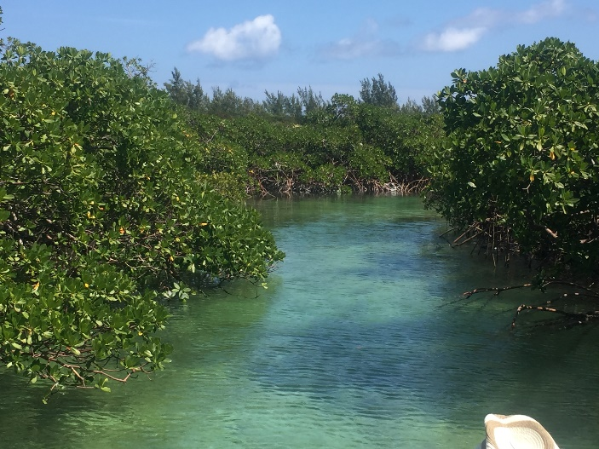
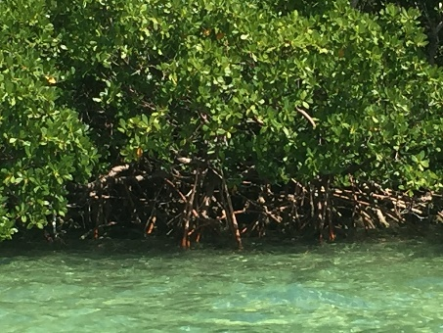
Day 13 If you have a boat, you know, things break. This morning started with repairs to one of the generators, and the water desalinization system. And, once again, Thomas the master mechanic, sailor, teller of tails, etc., worked his magic and got done just in time for a high tide. That enabled us to take the dingy back into the mangrove creeks, which were teeming with wildlife, from birds to fish, to rays and a huge number of turtles. A number of years back, the Bahamian Government outlawed the hunting of turtles and wow, are they making a comeback! Fundamental to all of this natural wonder is the mangrove tree. Found from Florida south, all around the shallow waters of the Caribbean islands, these unique trees make and retain the islands, protecting them from the winds and waters of hurricanes. Not only do they protect the land with their incredible system of roots, they are a terrific refuge for all of the wildlife that we saw today. While it won’t work in “hardcopy” hopefully those of you viewing this electronically will be able to open and view the film clips of turtles, rays, the mangrove creeks, and one clip that many fishermen would give up a valuable body part for, bonefish.
Tuesday, March 15th, 2016
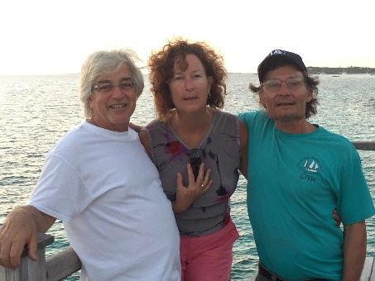
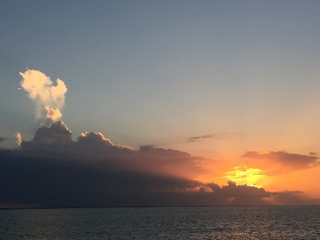
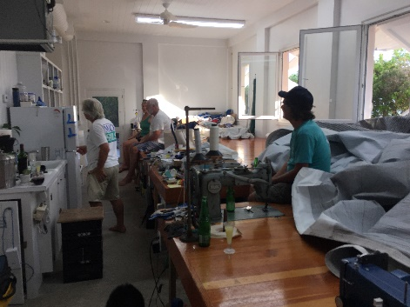
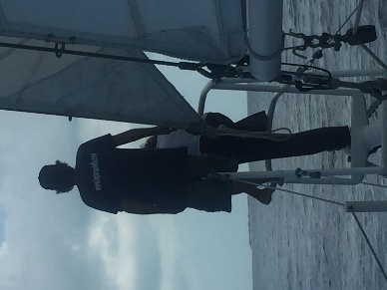
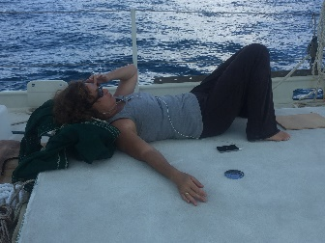
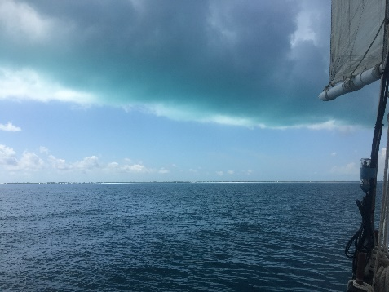
Day 14 Two weeks here and today is the last sail. And the Captain and the Admiral were ready to sail. This may be the earliest that the Admiral arose, and she was chomping at the bit. We knew that the wind was going to die at some point during the day and we had about 25 miles to put in from ManJack to Man ‘O War Cay. We headed out about 8 am and managed to get about half way before the wind totally died, so for the first time in 2 weeks, we were forced to employ the engine to motor the last miles to MOW Cay and the final anchorage – for me anyway. But, the adventure continued. Earlier in the sail, Thomas made the comment to me that sailors at sea could tell that they were near the Bahamas because that turquoise glow actually reflected from the clouds. A little hard to see as I did not have a polarized lens on my camera, but live through our sunglasses – holy smoke – the clouds were truly blue green! The Admiral was pretty stressed during the sail. Blue skies, gentle winds, it was hard on all of us. Thomas and I threw out fishing lines, I mean it was a hard day for all of us. Thomas and Linda spent some time up on the bow ostensibly keeping watch, but actually they were checking out the bottom for good lobster holes and other wildlife. And then, of course, when we got to our anchorage, it was off to see more friends. We met Berry and Barb, and Jay and Jan and their two daughters. Thomas and Jay are best buds. They are both sail makers, Thomas in the past and Jay is one of the top sailmakers in this part of the Bahamas. They have a great place. We spent some time in Jay’s sail loft as Thomas, Berry and Jay caught up on their goings on, and then walked out to their dock to catch the sunset.
Yesterday, Linda asked me if I was a fan of conch to which I replied a strong yes. So tonight when we returned to the boat, it was fresh from the Dominican roasted eggplant and carrots and conch burgers. Excellent!
Wednesday, March 16th
Day 15 Well, this is my last full day with Thomas and Linda. They have been extraordinarily good to me on this trip, sharing all facets of their life with me and enabling me to fulfil one of my dreams – going for a blue water sail. The trip has been far more than that though. Meeting their friends, sharing their life and the world they live in and the friends they have has been fantastic. For those of you who may read this entire story, I hope that I have been able to present at least a flavor of their world. It’s special and it’s definitely not for everyone, but to see the impact they have on the people around them and the love they get back is truly impressive.
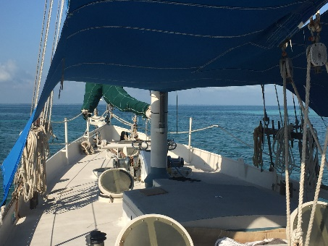
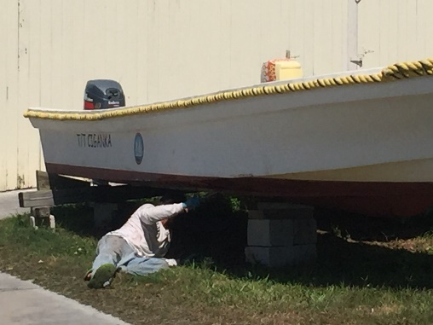
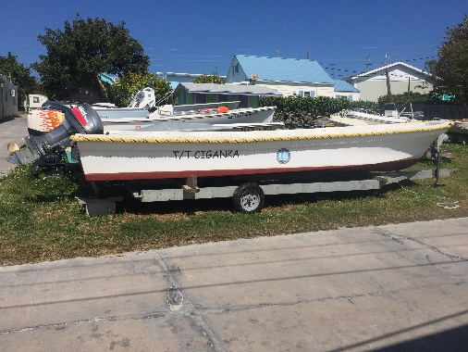
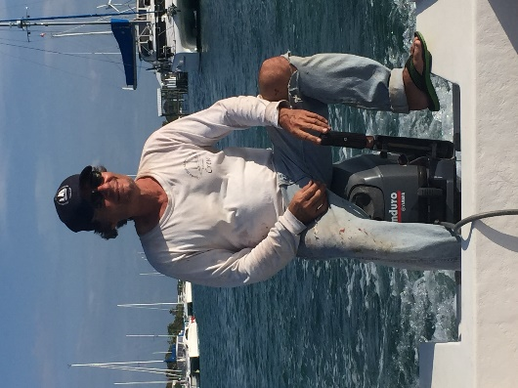
Today was pretty much a chore day. The first chore was a harsh reality one. You really know the sailing is over for now when the sail covers go on and the deck tarp goes up. Sigh!!!
Ciganka has 2 dinghies. One that they use in Luperon, and that was lashed to the boat on the way up, and one that they keep here in MOW Cay. It’s a little larger than most would think of as a dinghy – 24 feet long. That’s the one that they use for their charter business here – you need that when you have 20 boy scouts on board. Thomas and I sanded the bottom off to remove the barnacles and grass that was left from last season. Following that – thank heavens Thomas only had one roller – he applied the paint while I wondered the Cay and took a few pictures. For those of you who have sailed with Ciganka before, this is probably the dinghy that you’ll recognize. You’ll certainly recognize Thomas in his accustomed position as he drives around… Don’t mind the clothes – they’re for painting. And of course, since Thomas is a nautical MacGyver – give him a toothpick and a pocket knife and he’ll build you a boat and sail it around the world, the dinghy, which has been sitting in the boatyard for the last 7 months, started on the 3rd pull, and never stopped.
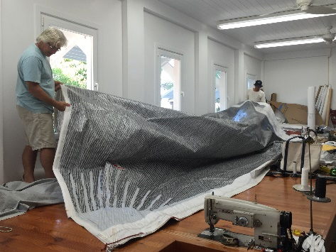
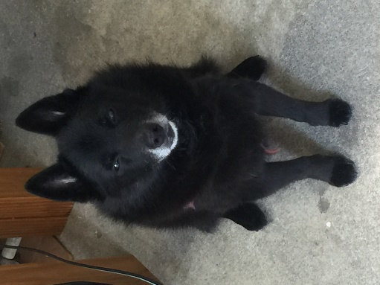
As you have previously read, there is no day in the life of Ciganka without a few more contacts with friends, in all kinds of ways. We stopped back by Jay’s house as he had asked Thomas to stop by to help him “flake” a very large sail that he’s repairing. For us landlubbers, that would be “fold” but sailors have their own special language. The first day we stopped by, I met their dog, who they call “Lick”. He’s very aptly named. He’s a really old little guy, getting cataracts, and has a little trouble with his hind legs, but he tends to walk up to strangers, sniff closely and lick any exposed skin. They have one friend though, who Lick kept focusing his attentions on - to one particular spot on his leg – turns out that the guy had a spot of skin cancer there. Lick was the first to figure this out, and the attention that he paid this spot led to the guy noticing the area and going to the doctor, which led to the diagnosis. Score another one for dogs that just know these things.
MOW Cay is a really picturesque place. It’s also different from a lot of the islands. For example, it is really beautiful, with lots of very nice trees, lawns and landscapes, but the island has no natural water (it’s a Cay, remember). All the water that is used for the islanders and for the landscaped is captured via water cisterns that rely on rainwater to stay replenished. I have included a few pictures that I took around the island just to try and capture a little of the flavor of the place.
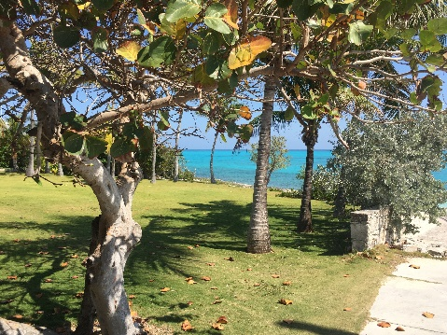
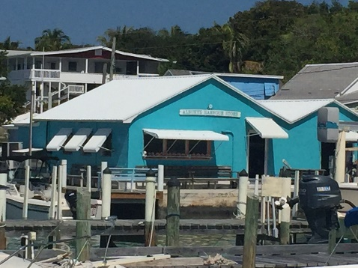
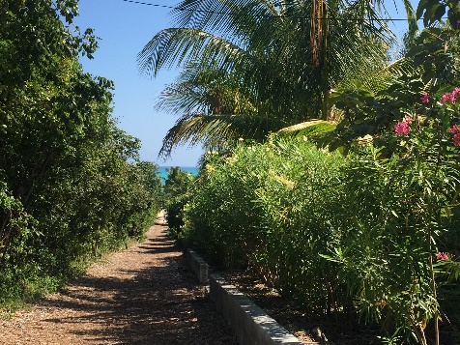
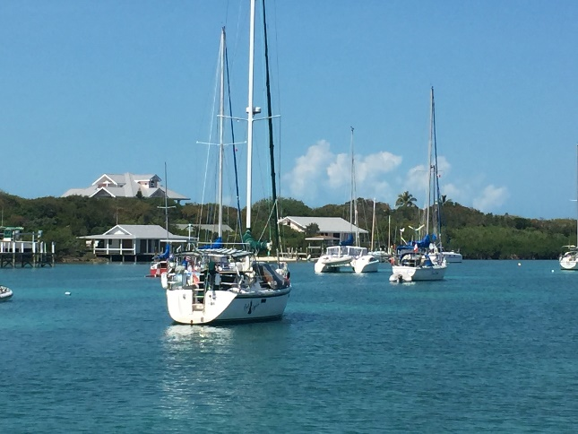
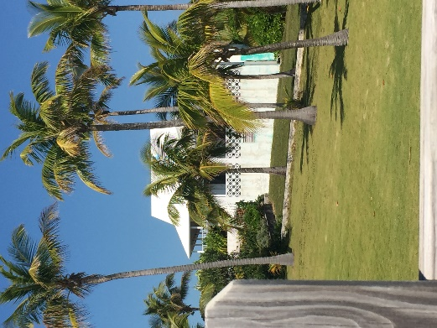
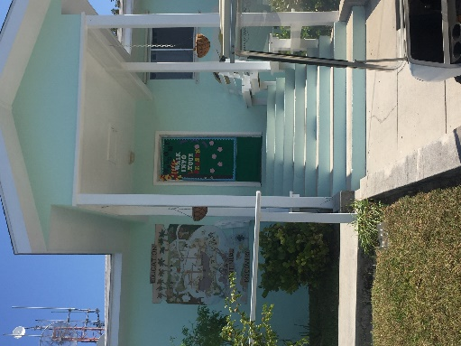
A

Thus ends this bucket list tale. Early tomorrow morning I will say my goodbyes to the Admiral and the Captain and start my journey home. A boat ride with yet more friends of Thomas and Linda over to Marsh Harbor and into the air with good old American Airlines. It will be sad to go, and the memories will last forever, but I miss my honey and it’s time to get home and back to our life together. Thomas and Linda have endured me for 15 days, and for those of you who know me, Lord knows that’s a gracious plenty.

Thomas, Linda and Ciganka have been more than incredible hosts. I met them last year as part of a charter, and loved them then. After this trip, I love them far more. They have carved out a life that is way outside the “norm” for most of us, but one that works for them and for so many of the people that they are in contact with. As far as the bucket list goes, they turned my bucket into a huge cistern, and it is overflowing with memories that I shall hold dear forever. A sincere thank you seems grossly inadequate. One day, I hope to have the opportunity in some small way to repay the kindness and the shear fun.
Fair winds and tight lines!
